**According to the Einstein readiness report**

**1. Einstein Lead Scoring** : *This feature is not available to you* as there are no leads in production org .You need at least 100 leads.

How can we achieve this?

· Create more Leads

· Convert more Leads

· At Least 1000 leads should be created in the last 6 months and at least 120 leads should be converted in accounts and contacts.

Einstein Lead Scoring uses data science and machine learning to discover your business’s patterns of lead conversion. Lead scoring will help you analyze or prioritize the leads to be converted.

It looks something like this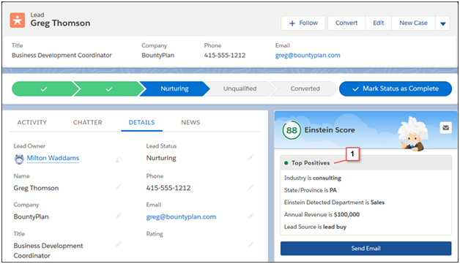

· We need to specify that Einstein to score all of your leads, or only those leads that meet criteria you specify.

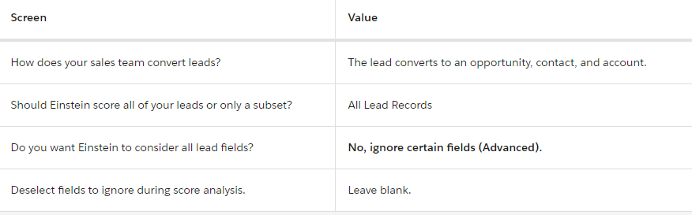

· You can specify up to 100 field filters for the leads you want to score. The CurrencyIsoCode field can’t be used in lead field filters.

· The following field data types also can’t be used in lead field filters.

1. Address

2. Date

3. Datetime

4. Double

5. Encrypted String

6. Geolocation

7. Multipicklist

8. Reference — However, the RecordTypeId reference field is supported.

9. Text Area

10. Time

The leads that you exclude are ignored when Einstein builds the predictive model.

Telling Einstein to ignore those fields yields more accurate lead scores. Before ignoring a field, make sure that the field doesn't affect the lead's chance of converting.

It takes up to 24 hours for lead scores to be available.

Setup the filters and various criterias for the lead scoring.

**2. Einstein Opportunity Scoring** : *This feature is not available to you*

How can we achieve this?

· Make sure you create more opportunities and update them through their life cycle. (Create and update more opportunities and run the readiness report again to see that feature is available).

· 200 closed won and closed lost opportunities are required in the last 2 years and should have a life span of 2 days.

Artificial intelligence helps you and your team prioritize opportunities so you can close more deals. Each opportunity is given a score, from 1 to 99.

It looks something like this

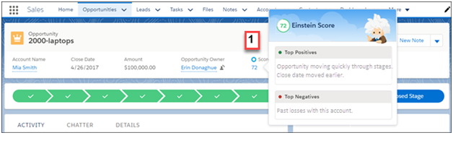

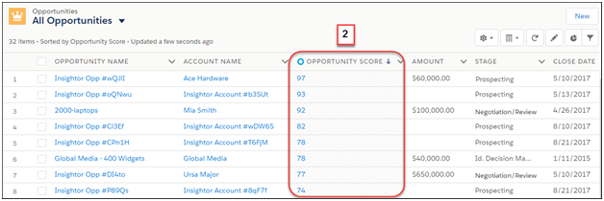

We need to set up a scoring field on a different layout.

3. **Einstein Opportunity Insights :** *This feature is available to you.*

Opportunity Insights includes predictions about which deals are likely to be won, reminders to follow up, and notifications when key moments in a deal take place.

INSIGHT TYPE

· Deal Predictions : See predictions based on recent activity and existing opportunity data, such as whether a deal is more or less likely to close, or if a deal seems unlikely to close in time.

· Follow-Up Reminders : Get reminders to follow up when a contact hasn’t responded in a while, or if there hasn’t been any communication related to an important opportunity for a significant period of time.

· Key Moments : Get notified when key moments related to a deal take place, such as if there’s new activity on an inactive opportunity.

Insights appear in the Einstein Insights component on opportunity records and the Home page.

It looks something like this

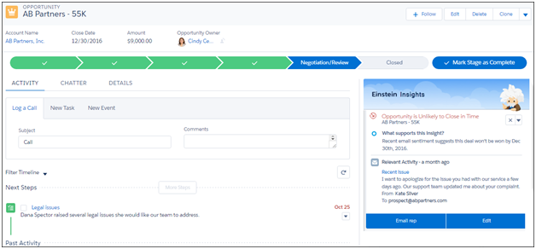

1. Einstein Activity Capture must be enabled and Einstein users need to connect their email and calendar to Salesforce.

2. Set Einstein Activity sharing settings to share activities with everyone.

3. We will add Assistant component and Einstein Insights component to the Home page of opportunity Lightning pages.

4. Make sure users have access to the Name and Type fields on the Opportunity object.

Note : It takes around 24 hrs to get insights.

4. **Einstein Account Insights:** *This feature is available to you.*

With Einstein Account Insights, you and your team stay informed about business developments and other key moments that affect your relationships with customers.

INSIGHT TYPE

· Key business development : News-related insights, such as whether the account is expanding, changing its company leadership, or is involved in merger and acquisition.

Insights appear in the Einstein Insights component on account records and the Home page.

It looks something like this

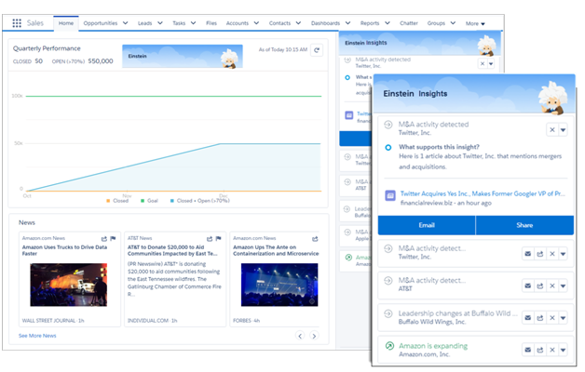

1. Einstein Activity Capture must be enabled and Einstein users need to connect their email and calendar to Salesforce.

2. Make sure users have access to the following Account fields: Activity, Name, Title, and Type.

3. Assistant component is added to the Home page and the Einstein Insights component is added to account Lightning pages.

4. Set Einstein Activity sharing settings to share activities with everyone.

5. It takes 24 hrs to get insights.

5. **Einstein Automated Contacts**: *It is available to you*

It finds new data by looking at your activities. For example, the title on suggested contacts comes from a person's email signature. If your admin chooses that new data is suggested to you, you see suggestions in the Einstein Insights component. If your admin chooses that data is added automatically, notifications alert you when new data is added to Salesforce. In both cases, the type of data determines who sees the suggestions or notifications.

For contacts : Suggestion appear at Home page and Account Record.

* For opportunity Contact Role : Suggestion appear at Home page and opportunity record.

It looks something like this

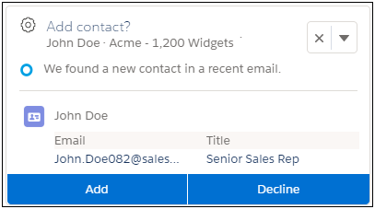

1. Make sure users have proper access to accounts, contacts, and opportunities

=> To add or decline contact suggestions, users need edit access on accounts. To add or decline opportunity contact role suggestions, users need edit access on opportunities, and read or edit access on contacts.

2. Einstein users have proper field-level security on all standard contact fields.

3. All required contact fields have a default value.

**6. Einstein Forecasting :** *It is not available to you*

How can we achieve this?

· Assign forecast managers in your forecast hierarchy.

· Have forecast users create at least one new opportunity each month over 12 months.

· Use the Amount field on more open opportunities.

It has the following:

**Prediction Column** : The prediction column shows the median predicted amount for each manager’s team. Predictions are based on opportunities within the Best Case and Commit forecast categories.

**Prediction Details :**

· Range—The full range of the prediction value, which is used to calculate the median value in the prediction column.

· Breakdown—A closer look at how Einstein came up with the prediction.

1. Wins from Existing Deals

2. Wins from New Deals

Prediction Trend Graph

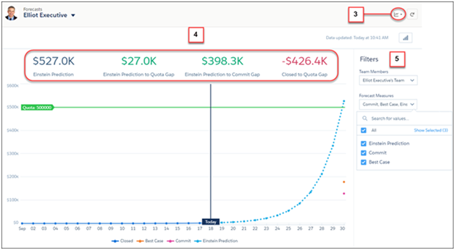

Prediction Summary Graph

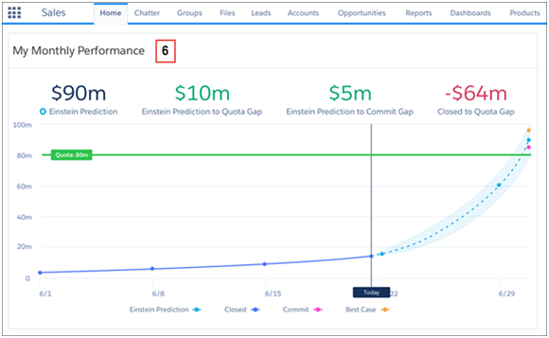

1. Collaborative Forecasting and forecast hierarchy must be set up before you can enable Einstein Forecasting.

=> Collaborative forecast is already setup

=> Forecast hierarchy need to set up

2. Enabling the Einstein forecasting.

7. **Einstein Activity Capture** : This feature is available to you

It captures email and events from your Microsoft or Google account and adds them to the activity timeline of related Salesforce records. This eliminates the need to manually log activities in Salesforce. Contact data is also captured and used to create email insights. Einstein Activity Capture also syncs events and contacts between Salesforce and your Microsoft or Google account.

1. Emails and events that users send and receive are automatically added to related records (accounts, contacts, contracts, leads, opportunities, and quotes) in Salesforce.
2. Emails and events appear on the activity timeline of the related records. Events also appear on the Salesforce calendar.
3. Contact data is captured from the connected account’s email and calendar. The data is used to generate email insights and recommended connections. The data isn’t added as Salesforce contact records.

After you connect an account, it takes up to 24 hours for Einstein Activity Capture to add your emails and events to related Salesforce records

1. Create a Configuration for Einstein Activity Capture.

2. Set Default Activity Sharing for Einstein Activity Capture Users.

3. Exclude Emails and Events from Being Added to Salesforce for All Users.(optional).

4. Give Users Access to Einstein Activity Capture.

5. Connect Salesforce to Your Microsoft Exchange Endpoint or Gmail Account.

6. Turn off lightning sync.

Notes : Starting in Winter ’21, Lightning Sync isn’t available to new Salesforce customers. Einstein Activity Capture is our long-term solution for syncing contacts and events between Microsoft® or Google applications and Salesforce.

8. **Einstein Email Insights :** If you use Einstein Activity Capture through a Sales Cloud Einstein, Inbox, or High Velocity Sales license, Email Insights is on by default when you turn on Einstein Activity Capture.

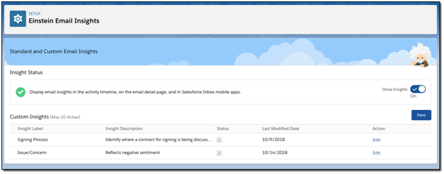

Examples:

**Issue/Concern**: Key words might include: *terrible, unhappy, disaster, upset, sucks, angry*

**Signing Process**: Key words might include: *signature, counter-sign, esignature, counter-sign*

So, when email insight is on it looks like below :

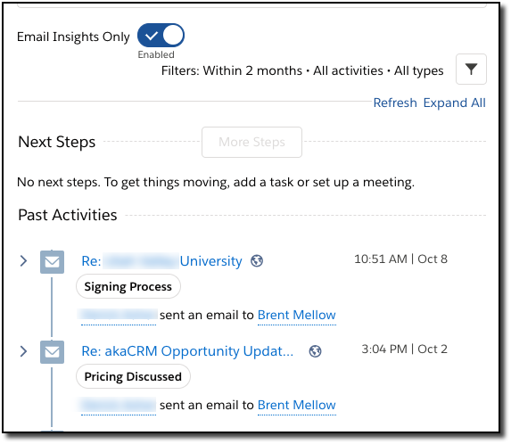

1. Einstein Activity capture must be enabled for users.
2. We will add words in the setup with the heading and description that will be shown on emails.

Requirement:

We need words from you and headings.

9. **Recommended Connections :** Give sales reps access to Recommended Connections to easily find new business by seeing which colleagues have the strongest connection to a prospect.

=> It gives you recommendations on which prospects can close a deal according to your relation with the prospects to help you find new businesses.

Add the Recommended Connections Lightning component to contact and lead Lightning pages.

Einstein Activity capture must be enabled for users.